Individual Assignment



TECHNOLOGY PARK MALAYSIA

CT122-3-2-BIS

Business Intelligence System

APU2F2411CS(DA)

|  |  |
| --- | --- |
| **Lecturer:** TS. Mohammad Namazee Bin Mohd Nizam | |
| Hand in Date | 2 May 2025 |
| Hand Out Date | 25 July 2025 |



**Presented by:**

Name : Faiyad Mahabub Tasin

TP Number : TP077983

**Table of Contents**

**1.0: Introduction** 3

1.1: Company Profile 4

1.2: Aims & Objective 5

**2.0: Methodology** 6

2.1: CRISP-DM Process Phases 6

2.2: Justification for CRISP-DM 8

**3.0: Business Intelligence Solution** 9

3.1: Data Source 9

3.2: Data Source View 10

3.3: Cube Structure 11

3.4: Dimension Usage 12

3.4.1: Promotion Dimension 12

3.4.2: Date Dimension 13

3.4.3: Sales Territory Dimension 15

3.4.4: Customer Dimension 17

3.4.5: Product Dimension 18

3.4.6: Product Category Dimension 20

3.4.7: Product Subcategory Dimension 21

3.5: MDX Calculation 22

3.5.1: Total Sales Amount’s Calculation 23

3.5.2: Total Cost of Product’s Calculation 24

3.5.3: Internet GPM’s Calculation 25

3.5.4: Reseller GPM’s Calculation 26

3.5.5: Total GPM’s Calculation 27

3.5.6: Cost Ratio’s Calculation 28

3.5.7: Profit Margin’s Calculation 29

**4.0: Business Intelligence Report (Analysis)** 30

4.1: Overall Report for AdventureWorks 30

4.2: Global Sales Distribution Report 31

4.3: Regional Sales Growth Trends Report 32

4.4: Customer Demographics Report 34

4.5: Yearly Sales Trend Analysis Report 35

4.6: Key Profitability Metrics Report 36

4.7: Channel Performance by Region 37

4.8: Revenue By Product Category 38

**5.0: Conclusion** 39

**6.0: References** 40

# **1.0: Introduction**

In recent times, organizations are getting competitive day by day, and they have to rely on accurate real-time data to make strategic decisions for better profits. Modern technologies have shaped out in tackling such challenges, where they transform the data into meaningful information which highly expresses the hidden aspects of their businesses, which opened up doors to many possibilities. These possibilities have helped businesses to make better decisions, which in turn have helped them out in getting higher profits than before, and they later expanded their businesses globally.

One of the modern technologies includes Business Intelligence solutions. A business intelligence (BI) solution is normally constructed on a centralized data storage with the data being extracted, transformed, and loaded (ETL), which is then navigated using Online Analytical Processing (OLAP) engines and finally displayed in dashboards and reports that are easy to understand. These systems allow stakeholders to have access to an interactive dashboard, which helps them to recognize hidden aspects of their businesses. Businesses must evaluate the benefits of a BI implementation in order to align with modern technologies that meets with strategic objectives. In the case of such companies such as AdventureWorks, which are planning an international expansion, a strict BI assessment would make sure that the insights are supportive for competitive standing and strategic growth.

## 1.1: Company Profile



Figure 1: AdventureWorks Bike Shop Logo

AdventureWorks was founded in the year 2002, and its main headquarters are in Bothell, Washington, in the United States. As years have passed, the company has grown into a dominant force in global bicycle manufacturing and component OEM (Original Equipment Manufacturer) supply. The company supplies premium bicycles and precision parts, which include gear assemblies, chains, etc. It holds 55% of the U.S. market, where it generates approximately USD 89.84 million in annual revenue. AdventureWorks has production plants in Portland (USA), Dortmund (Germany), etc. This helps to maintain consistent product quality and rapid delivery across North America, Europe, and Asia‑Pacific markets. The company is backed by 8000 employees, where it has a strong, vigorous R&D budget that continually pioneers technological breakthroughs to uphold its leadership in product quality and innovation.

As AdventureWorks expands internationally, it needs to balance a combination of distribution channels, where approximately half of them are traditional retail partners. About 30% of it is directed to consumer e-commerce, and 20% to third-party distributors. The company is always trying its best to protect efficiency and customer satisfaction.

## 1.2: Aims & Objective

**Aim:** Transform AdventureWorks’ raw data into actionable intelligence by executing a structured Business Intelligent process which executes data warehousing, multidimensional modelling, dashboard visualization, and executive reporting.

**Objectives:**

* **To stage and integrate** all source data in SQL Server Management Studio (SSMS) to ensure a clean, consolidated enterprise data warehouse.
* **To design and deploy** an SSAS cube in Visual Studio that models critical measures (e.g., monthly sales, gross profit margins) alongside dimensions such as channel, product category, region, and customer demographics that will enable rapid OLAP queries which would power both the Financial Performance and Market Analysis.
* **To build interactive Power BI dashboards** that surface sales, customer insights through dynamic visuals and user‑driven exploration.
* **To compile and distribute** a Business Performance Management (BPM) report that synthesizes findings and strategic recommendations for senior leadership.

# **2.0: Methodology**

The methodology to be used for conducting the business intelligent system is the Cross-Industry Standard Process for Data Mining (CRISP-DM). The Cross-Industry Standard Process for Data Mining (CRISP-DM) is a popular and practical approach for guiding data mining and business intelligence (BI) projects. The leaders of Daimler-Benz first proposed the methodology (*1. Definition — the Crisp-DM Methodology*, n.d.), which is now known as the Board of Management of Mercedes-**Benz** Group AG (Mercedes-Benz Group, n.d.). CRISP‑DM is a standard methodology in the industrial world since it is flexible and provides clear steps on what should be done. It also supports iteration for each step conducted. It breaks the work into six major phases.

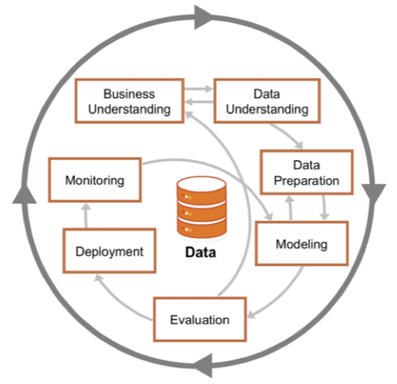

Figure 2: Crisp-DM Process Model (Luna, 2022)

## 2.1: CRISP-DM Process Phases

1. **Business Understanding:** In business understanding, we try to clarify what are our business goals, which is needed for achieving a particular business target. In this step business Analyst work with leaders or board members of the company (Chumbar, 2023), to clear out the business goals that need to be addressed. The business goals that need to be addressed for AdventureWorks are:
   * 1. Expanding the market globally, where the company wants to expand their market presence from 55% US dominance to global reach.
     2. Understanding and optimize performance between traditional resellers and e-commerce channels in order to determine optimal channel mix for different markets and regions.
     3. Gain a holistic view of current global business performance that focuses on sales performance, market trends and customer preferences.
2. **Data Understanding:** In this phase, data is collected from different sources and explored further to describe what the data is about and verify data quality in order to meet the business requirements, (Chumbar, 2023). For AdventureWorks, a data source is already present in the SSMS database, where it has relevant tables and key attributes for reaching our target goals.
3. **Data Preparation:** In this phase, once the dataset is explored, we start to prepare the dataset for modelling phase. The preparation stage involves several stages where the raw dataset goes through in order to be perfected enough for building models. The raw dataset will not go through each phase, but will be decided on what stage to move into based on the exploration results. The steps include:
   * 1. The data is cleaned out for any incorrect values that might hinder our model evaluation, (Chumbar, 2023).
     2. It is then scaled properly, if necessary, based on our data exploration to ensure variables are in a comparable scale, (Sharma, 2025).
     3. Standardizing inconsistent formats such as currency, data, etc, if necessary, (Sharma, 2025).
     4. Impute missing values with appropriate techniques such as mean, median, mode or use any other valid methods to make the dataset complete, (Sharma, 2025).
     5. Selection of data that would be appropriate for specific visualizations, (Sharma, 2025).
4. **Modelling:** After the dataset is explored and prepared it is put into the modelling phase where it will use many modelling techniques (Sharma, 2025), such as making OLAP cubes and MDX queries to answer questions like “Which products are growing fastest in each market?” and “How do sales margins compare by region?” with the help of key performance indicator such as total sales, gross margin, market growth rate, conversion rate that would help to make interactive dashboard.
5. **Evaluation:** After the model and dashboard have been made, we check whether the results match the business goals, (Sharma, 2025). The BI team of AdventureWorks will review the dashboard and reports with stakeholder to determine whether the insights are meeting their business goals or not.
6. **Deployment:** The dashboard is subsequently published into the real world for scheduled reports and mobile-friendly visuals to show real-time metrics. Instruction on how to use the system is documented and trained in this phase, where the team in AdventureWorks will know how to use the system. Monitoring is set up as well to make sure it aligns with changing business needs, (Chumbar, 2023).

## 2.2: Justification for CRISP-DM

CRISP‑DM is well-suited for AdventureWorks since it starts with understanding the business goals first, and it can loop back for feedback from stakeholders on whether the business goals are being met or not. Each iterative steps allow the BI solution to stay focused and clear, which would result in delivering reliable and actionable insights that would contribute to supporting its global expansion and operational objectives.

# 

# **3.0: Business Intelligence Solution**

## 3.1: Data Source

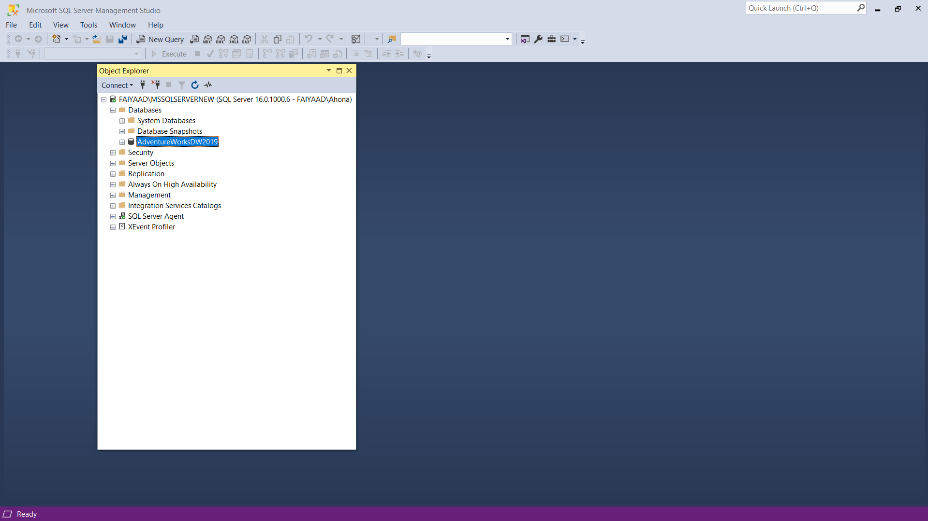

Figure 3: The data source designer

The image showcases the source of the data from the SQL Server Management Studio which acts as the main data warehouse of the company. This data will then be connected to visual studio using the SQL Server Analysis Services (SSAS) project for reliable data retrieval from the data warehouse which makes the basis of constructing the multidimensional model.

## 3.2: Data Source View

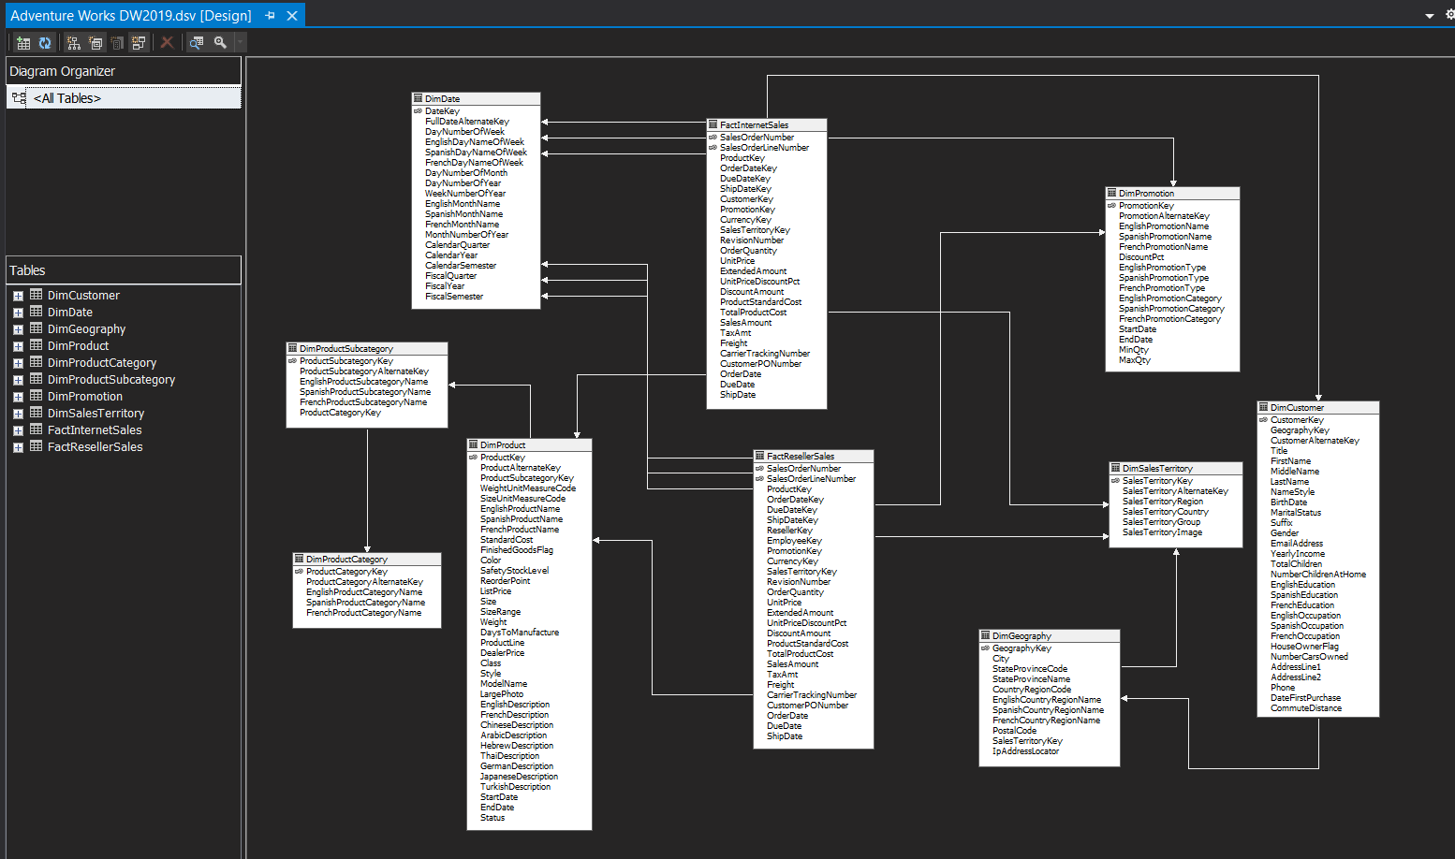

Figure 4: Data Source View of AdventureWorks 2019

The image showcases the source of the data from the SQL Server Management Studio, which acts as the main data warehouse of the company. This data will then be connected to Visual Studio using the SQL Server Analysis Services (SSAS) project for reliable data retrieval from the data warehouse, which forms the basis of constructing the multidimensional model.

## 3.3: Cube Structure

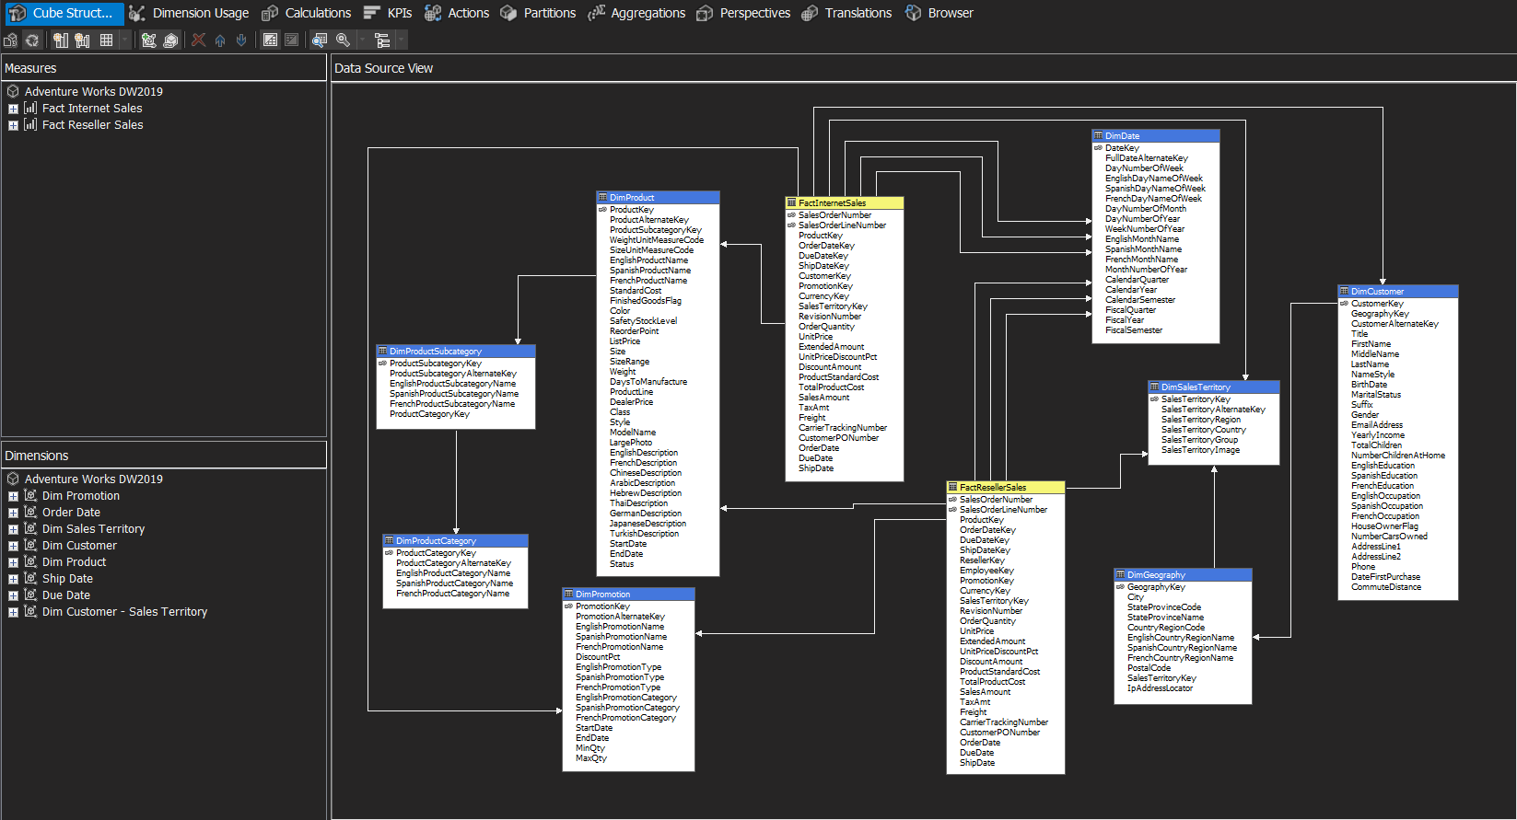

Figure 5: The cube structure of AdventureWork 2019

The AdventureWorks DW2019 cube has been developed using a multidimensional design that is optimized for Online Analytical Processing (OLAP). As shown in Figure 5 above, the cube features two key measured groups**:** *FactInternetSales* and *FactResellerSales*. These measure groups include essential metrics such as Sales Amount, Order Quantity, Unit Price, Extended Amount, Discount Amount, Product Standard Cost, Total Product Cost, Tax Amount, and Freight. This allows a comprehensive analysis of sales performance across both internet and reseller channels.

The cube integrates eight dimensions: Product, Customer, Sales Territory, Promotion, and three date-related dimensions (Order Date, Ship Date, Due Date). This dimensional setup allows users to slice and dice data across various perspectives including product categories, customer demographics, geographic regions, promotional strategies, and temporal trends.

## 3.4: Dimension Usage

### 3.4.1: Promotion Dimension

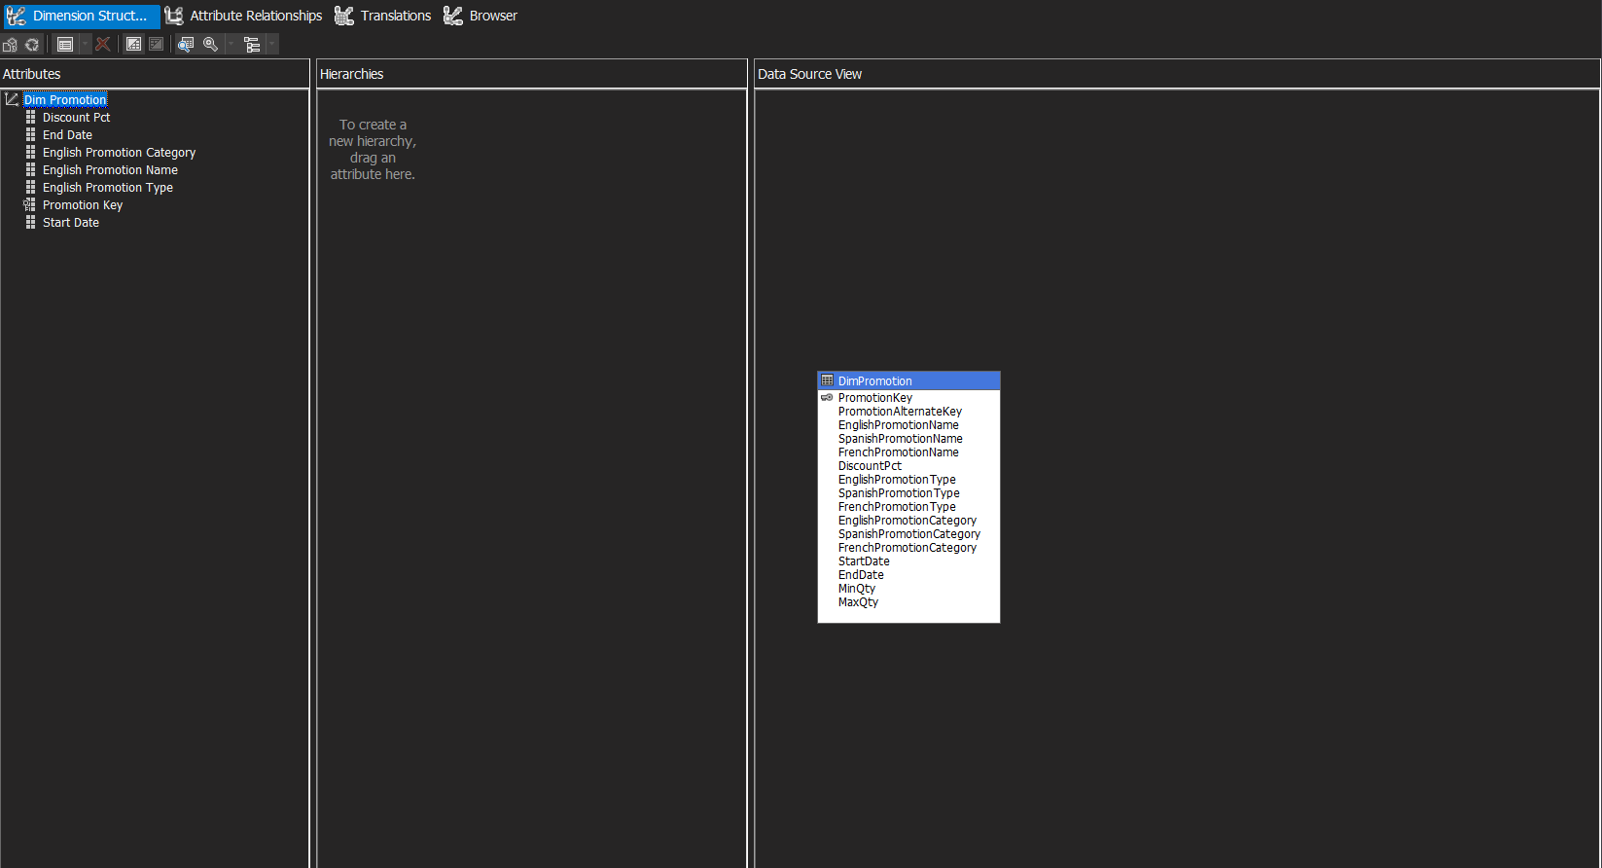

Figure 6: The Promotion Dimension Structure

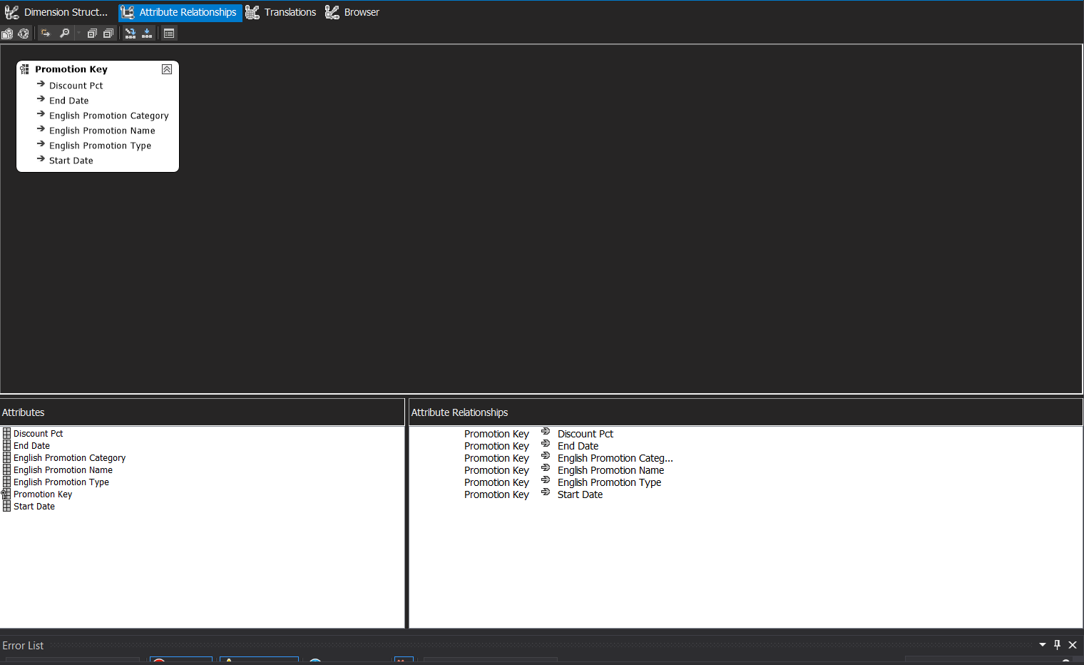

Figure 7: The Promotion Attribute Relationship

Figure 6 shows the Dimension Structure tab for the Promotion dimension. It outlines the key attributes selected from the DimPromotion table where it includes: PromotionKey, DiscountPct, English Promotion Name, English Promotion Type, English Promotion Category, Start Date, and End Date

Figure 7 presents the Attribute Relationships diagram for the Promotion dimension, where it visually shows the relationship between the primary attribute (PromotionKey) and its related attributes.

### 3.4.2: Date Dimension

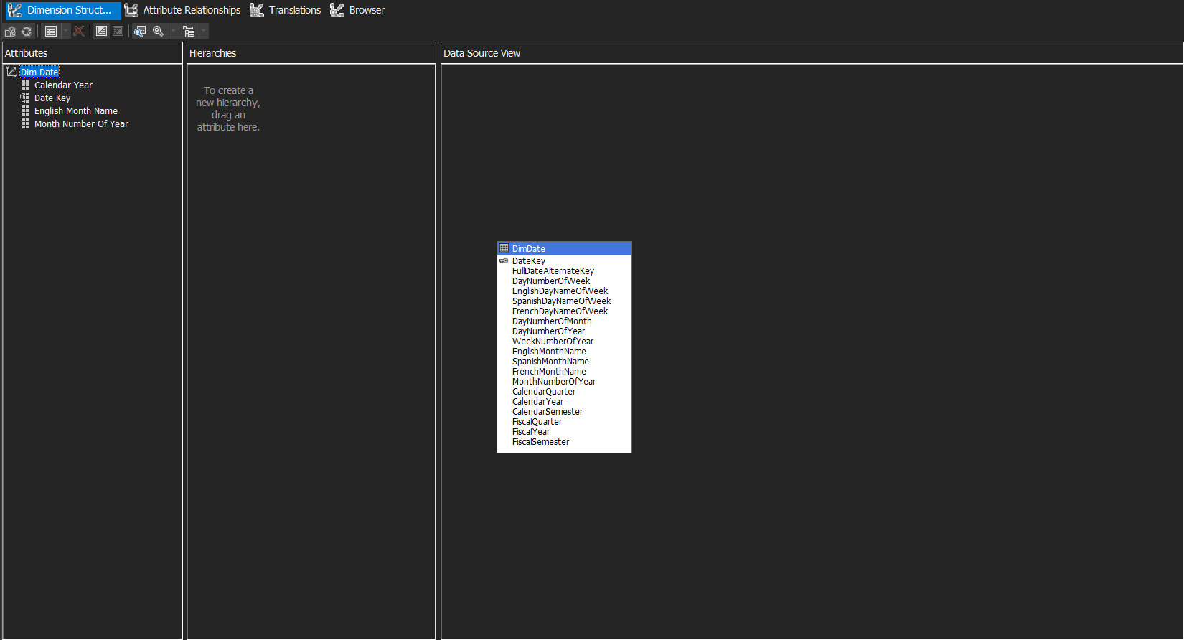

Figure 8: The Date Dimension Structure

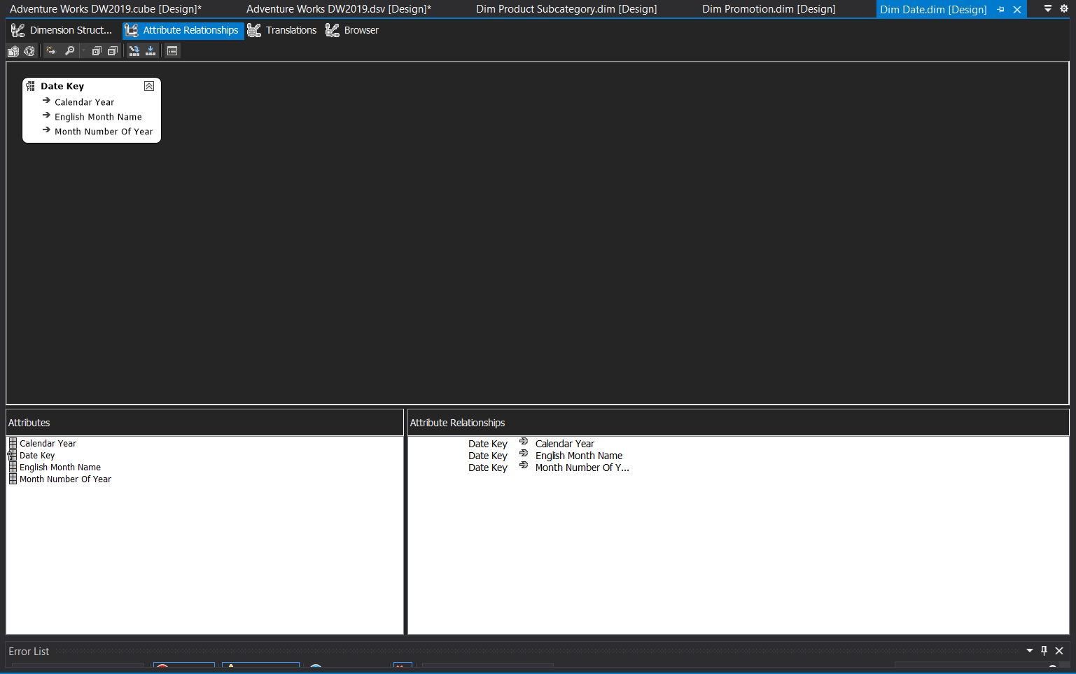

Figure 9: The Date Attribute Relationship

Figure 8 displays the Dimension Structure for the Date dimension. The attributes selected include Date Key, Calendar Year, English Month Name, and Month Number of Year.

Figure 9 shows the Attribute Relationships diagram for the Date dimension. It illustrates how each attribute is related to the Date Key, which is used as the anchor for aggregating time-based data across the model. A user hierarchy was not created in this dimension because the current report design focuses on flat, filterable elements.

### 3.4.3: Sales Territory Dimension

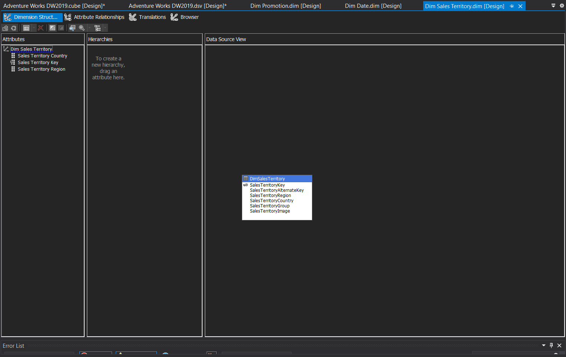

Figure 10: The Sales Territory Dimension

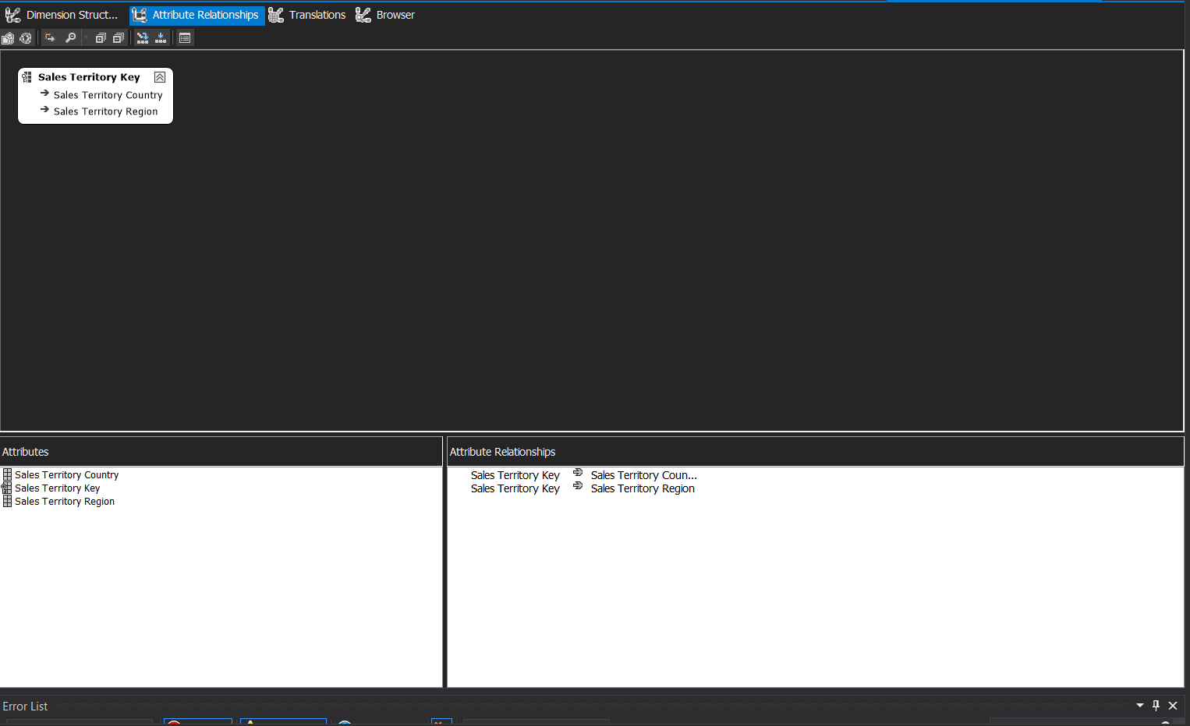

Figure 11: The Sales Territory Attributes Relationship

Figure 10 presents the Dimension Structure tab for the Sales Territory dimension. The attributes selected include Sales Territory Key, Sales Territory Country, and Sales Territory Region.

Figure 11 shows the Attribute Relationships diagram which shows the connections between the Sales Territory Key attribute with its dependent attributes.

### 3.4.4: Customer Dimension

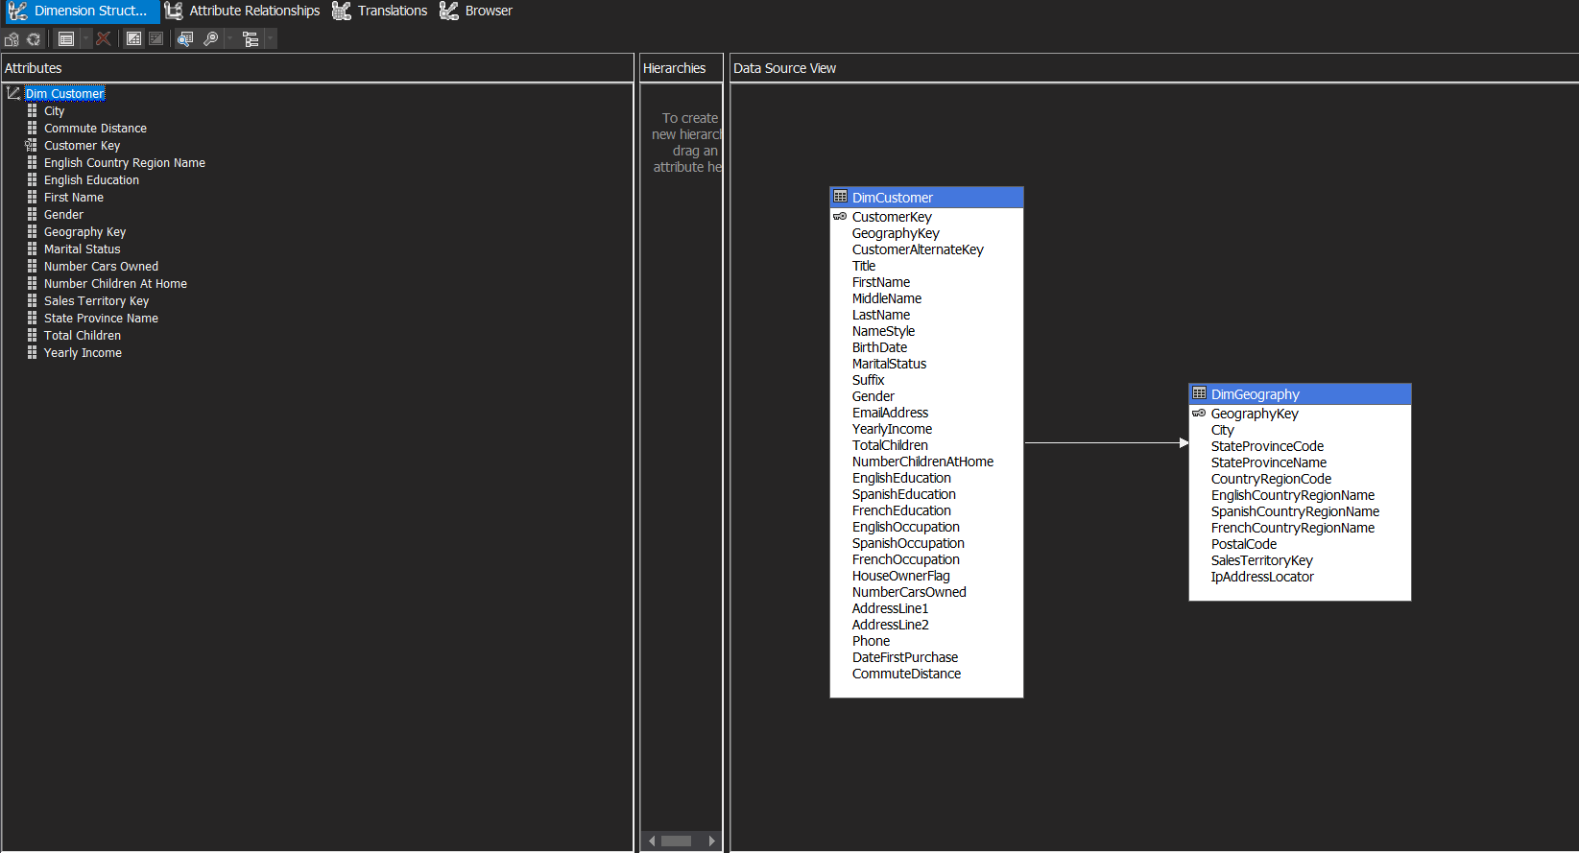

Figure 12: The Customer Dimension

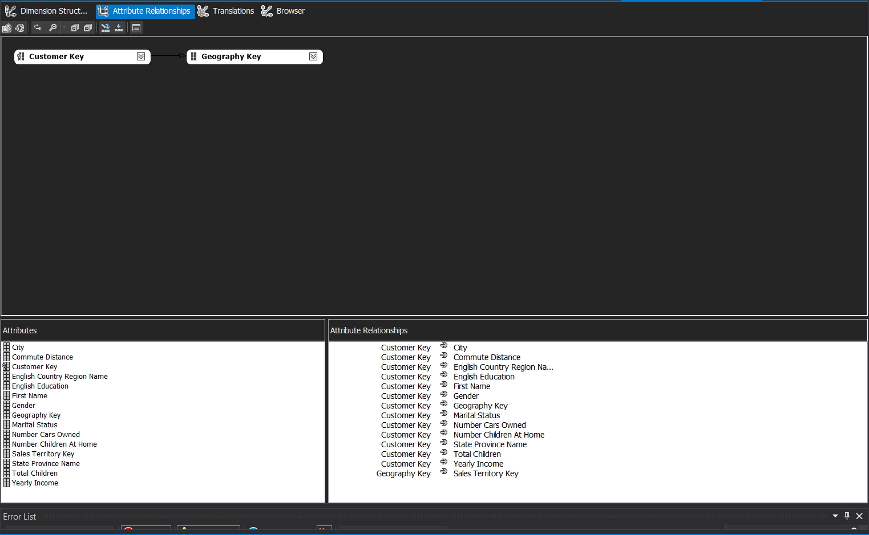

Figure 13: The Customer Dimension Attributes Relationship

Figure 12 shows dimension structure for Customer dimension. Attributes such as Customer Key, First Name, Gender, Marital Status, Education, Yearly Income, Commute Distance, and Geography Key are included inside the dimension.

Figure 13 displays the Attribute Relationships diagram. It demonstrates how the Customer Key is connected to other customer-specific attributes, and how Geography Key is used to establish relationships with location-based data.

### 3.4.5: Product Dimension

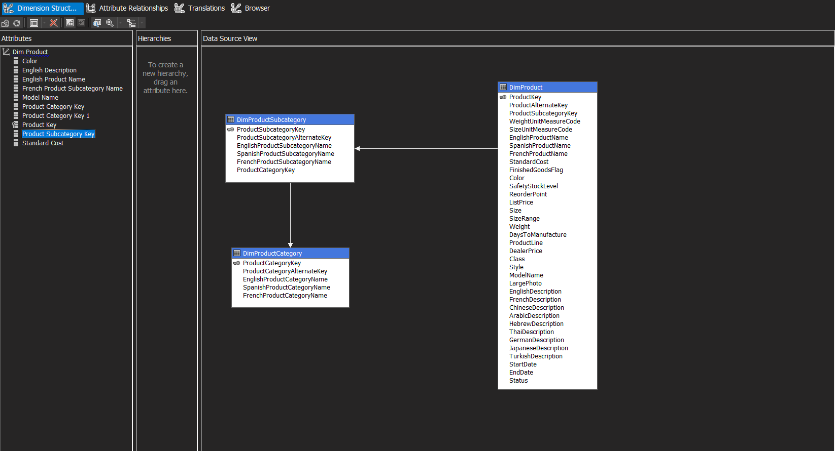

Figure 14: The Product Dimension

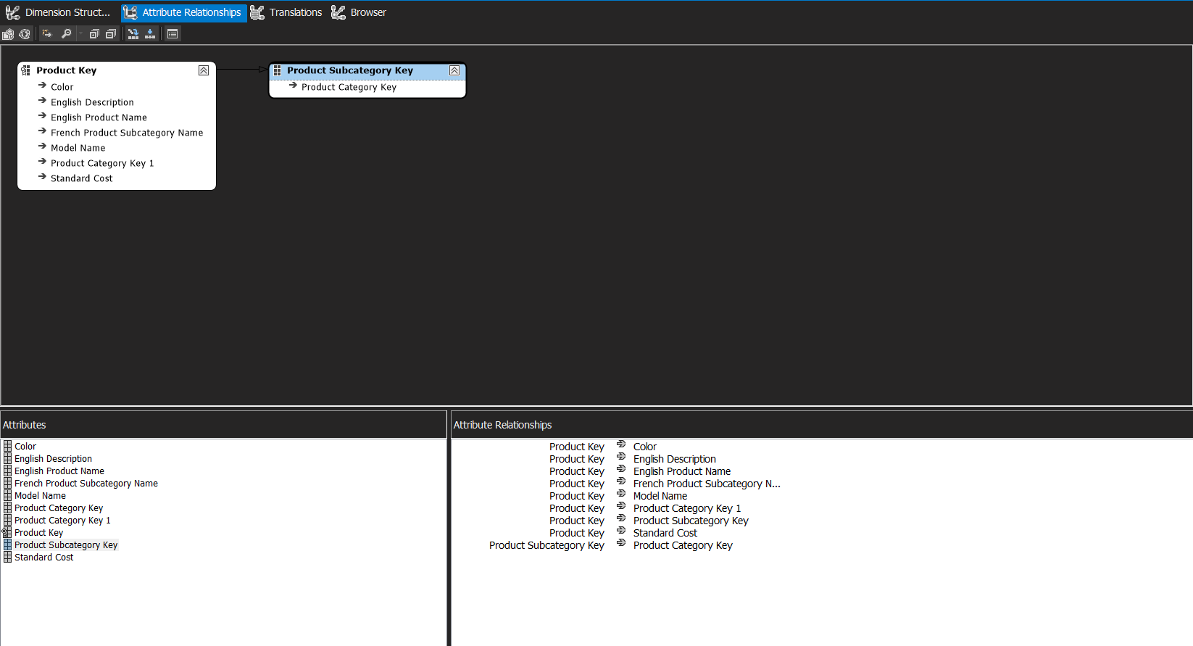

Figure 15: The Product Dimension Attribute Relationship

Figure 14 displays the Dimension Structure for the Product Dimension. Key attributes such as Product Key, Product Subcategory Key, Product Category Key, English Product Name, English Product Category Name, English Product Subcategory Name, Model Name, Colour, Standard Cost, and English Description are used to support detailed product-level sales analysis.

Figure 15 shows the Attribute Relationships diagram. It reflects the structure where Product Key is the central attribute connected to all others, while Product Subcategory Key also links to Product Category Key to maintain proper category-subcategory hierarchy integrity.

### 3.4.6: Product Category Dimension

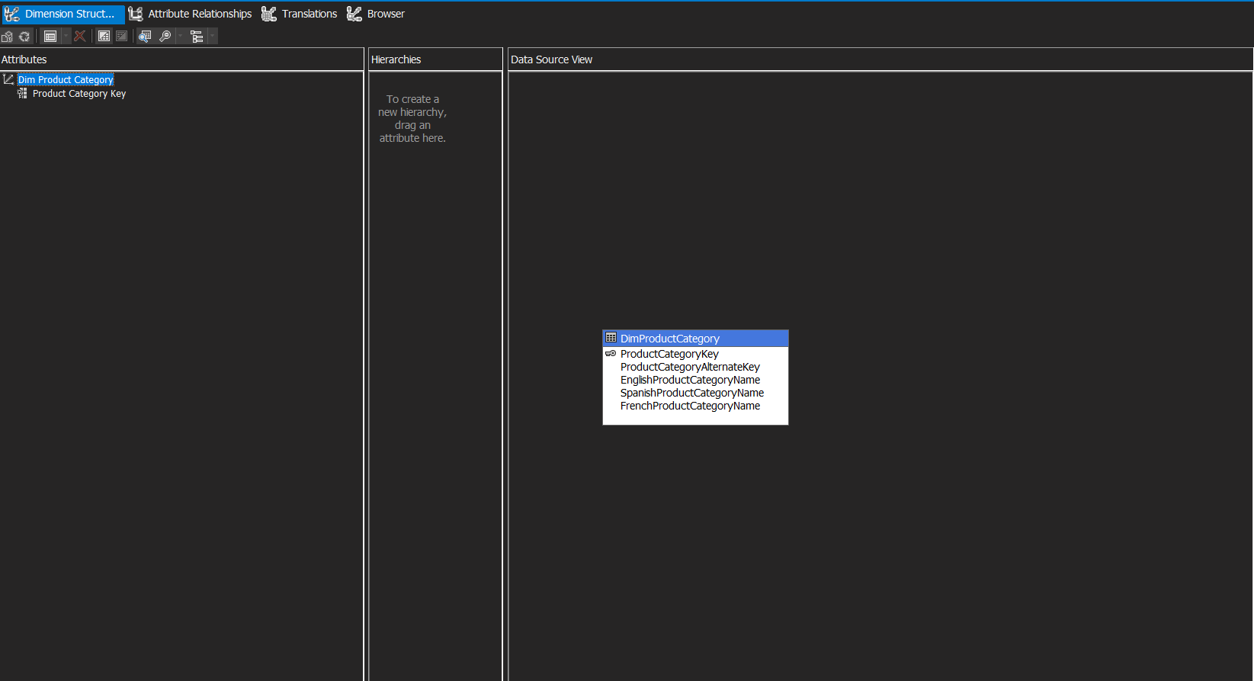

Figure 16: Dimension for Product Category

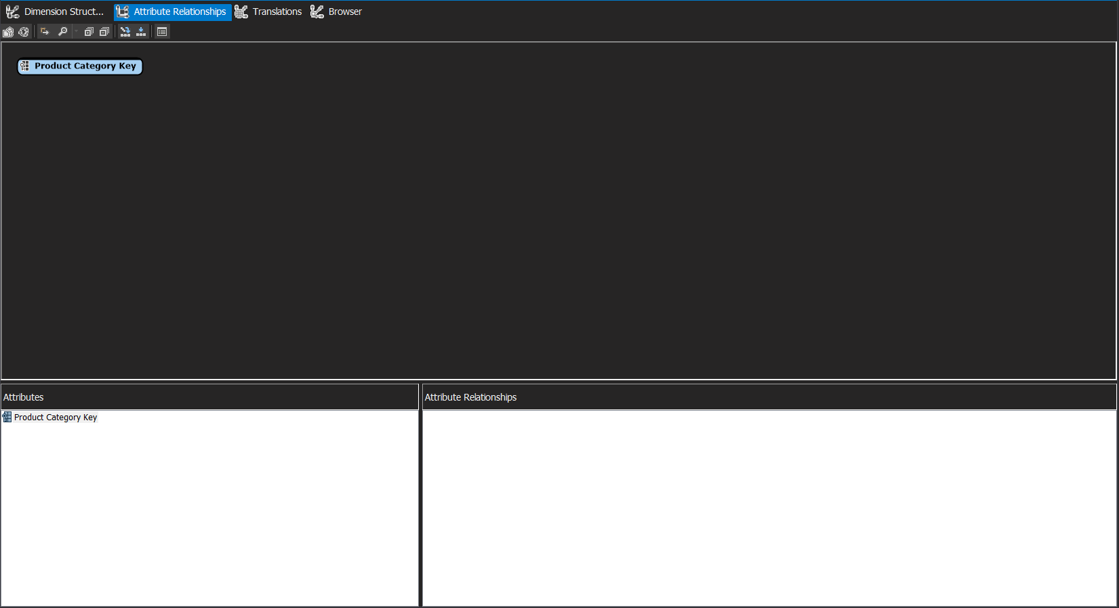

Figure 17: The Product Category Dimension Attribute Relationship

Figure 16 shows the Dimension Structure for the Product Category Dimension where key attributes include Product Category Key, Product Category Alternate Key, English Product Category Name, Spanish Product Category Name, and French Product Category Name.

Figure 17 shows the Attribute Relationships diagram for the Product Category Dimension. The structure demonstrates a simplified hierarchy where Product Category Key serves as the primary attribute.

### 3.4.7: Product Subcategory Dimension

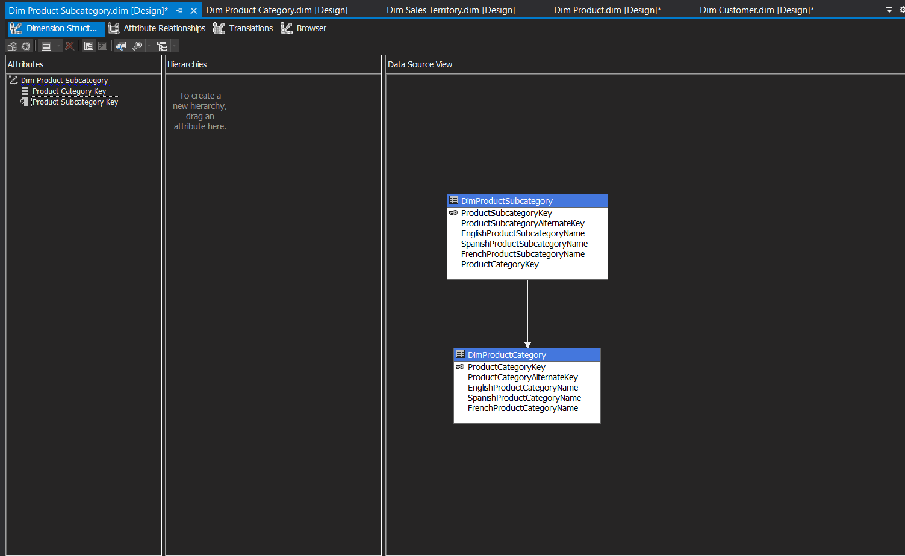

Figure 18: The Product Sub-Category Dimension

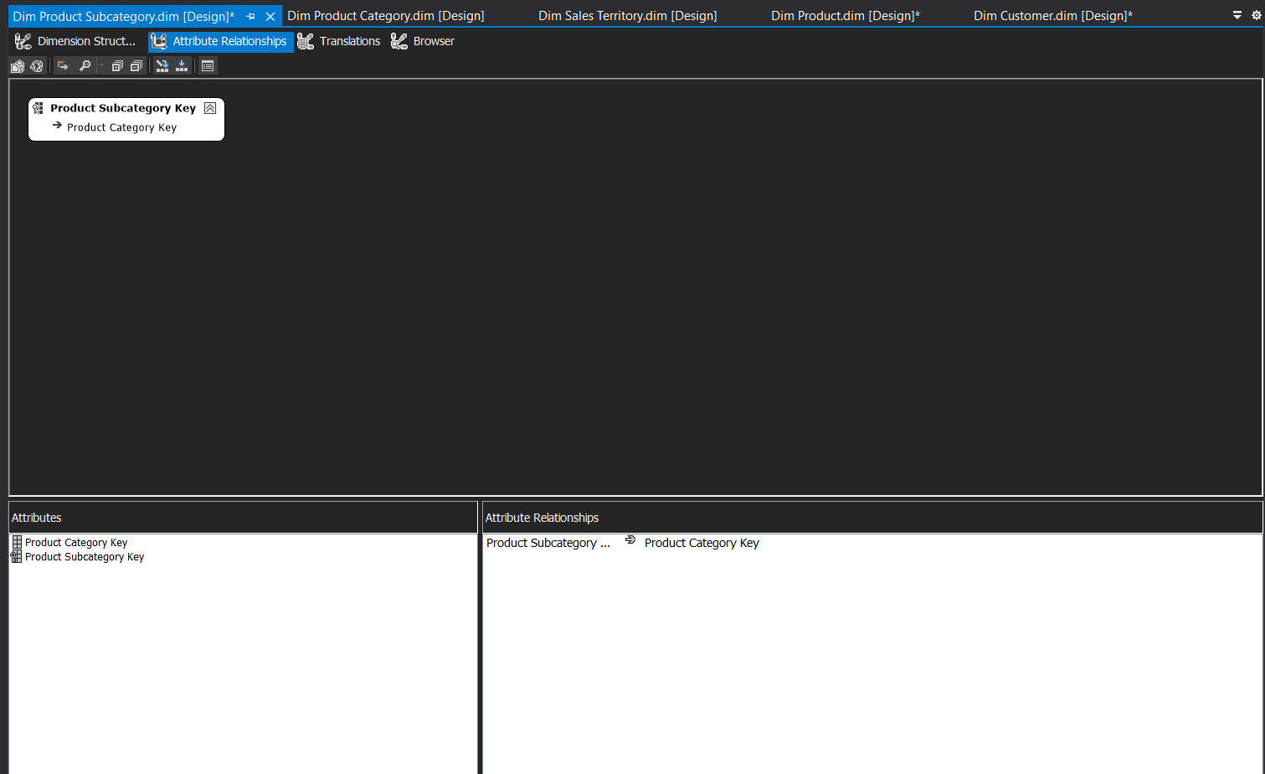

Figure 19: The Product Sub-Category Dimension Attribute Relationship

Figure 18 shows the Dimension Structure for the Product Subcategory Dimension. Key attributes include Product Subcategory Key, Product Subcategory Alternate Key, English Product Subcategory Name, Spanish Product Subcategory Name, French Product Subcategory Name, and Product Category Key.

Figure 19 shows the Attribute Relationships diagram for the Product Subcategory Dimension. The structure showcases a clear hierarchical relationship where Product Subcategory Key serves as the primary attribute while maintaining a direct relationship to Product Category Key.

## 3.5: MDX Calculation

In this project, Multidimensional Expressions (MDX) calculations were created to enrich the cube with custom business logic and performance metrics which would tailor AdventureWorks' analytical needs.

### 3.5.1: Total Sales Amount’s Calculation

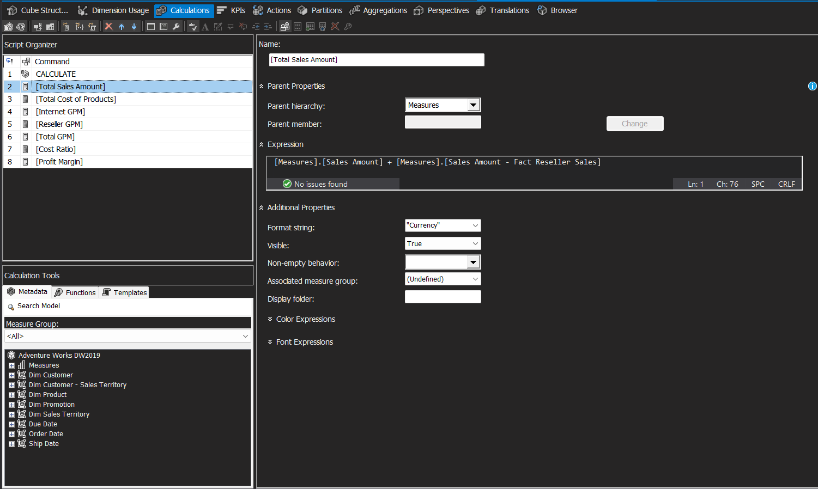

Figure 20: Total Sales Amount MDX Calculation

Figure 20 shows the calculated measure for "Total Sales Amount" that combines sales amounts from both Internet and Reseller sales channels which formatted as currency to provide a consolidated view of total revenue across all sales channels.

### 3.5.2: Total Cost of Product’s Calculation

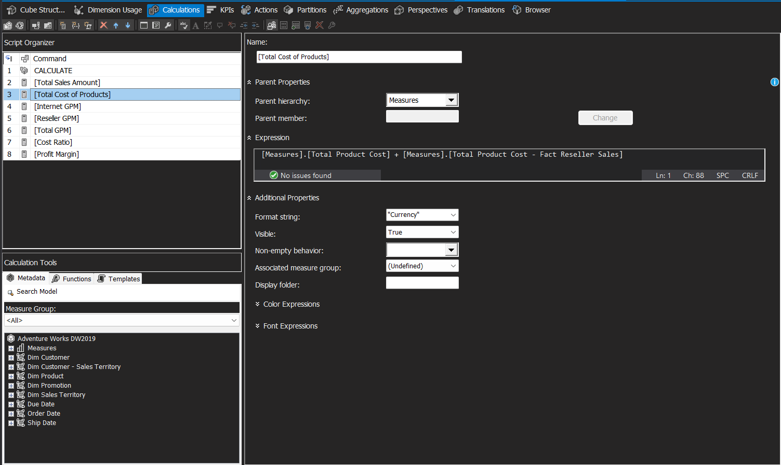

Figure 21: Total Cost of Product MDX Calculation

Figure 21 shows the calculated measure setup for "Total Cost of Products" that sums Total_Product_Cost measures by the addition of internet and reseller sales.

### 3.5.3: Internet GPM’s Calculation

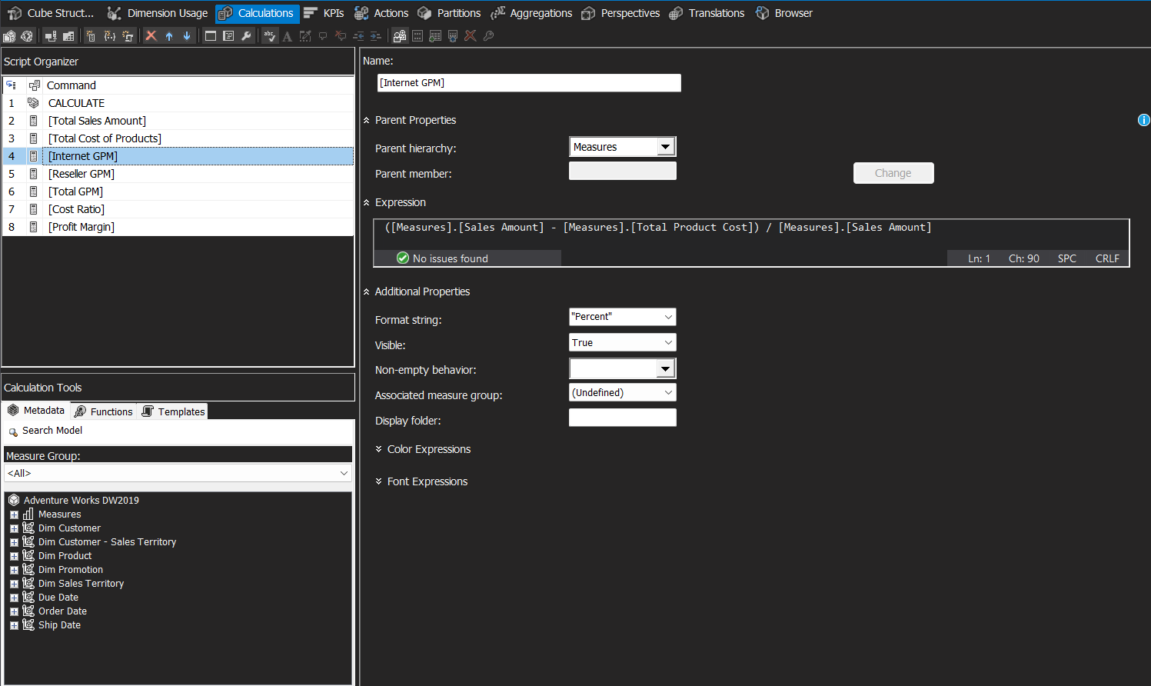

Figure 22: Internet GPM Calculation

Figure 22 shows "Internet GPM" (Gross Profit Margin) which is a calculated measure that calculates the profitability ratio for Internet sales using the formula (Sales Amount - Total Product Cost) / Sales Amount. The measure is formatted as a percentage to provide margin analysis specifically for the Internet sales channel.

### 3.5.4: Reseller GPM’s Calculation

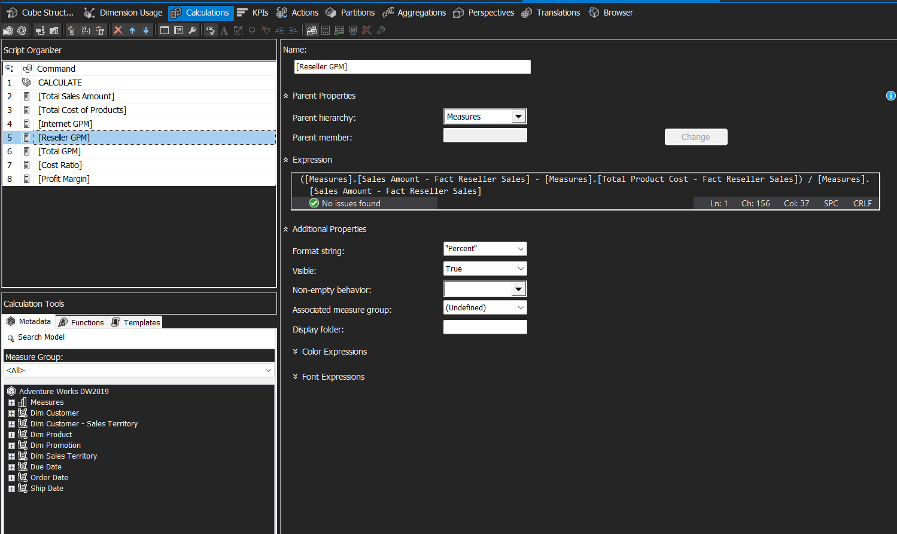

Figure 23: Reseller GPM Calculation

Figure 23 provides a measure calculation which is known as "Reseller GPM" that computes the gross profit margin for reseller sales using MDX expressions that calculate (Reseller Sales - Reseller Costs) / Reseller Sales. It is formatted as percentage in order to analyse profitability within the reseller channel.

### 3.5.5: Total GPM’s Calculation

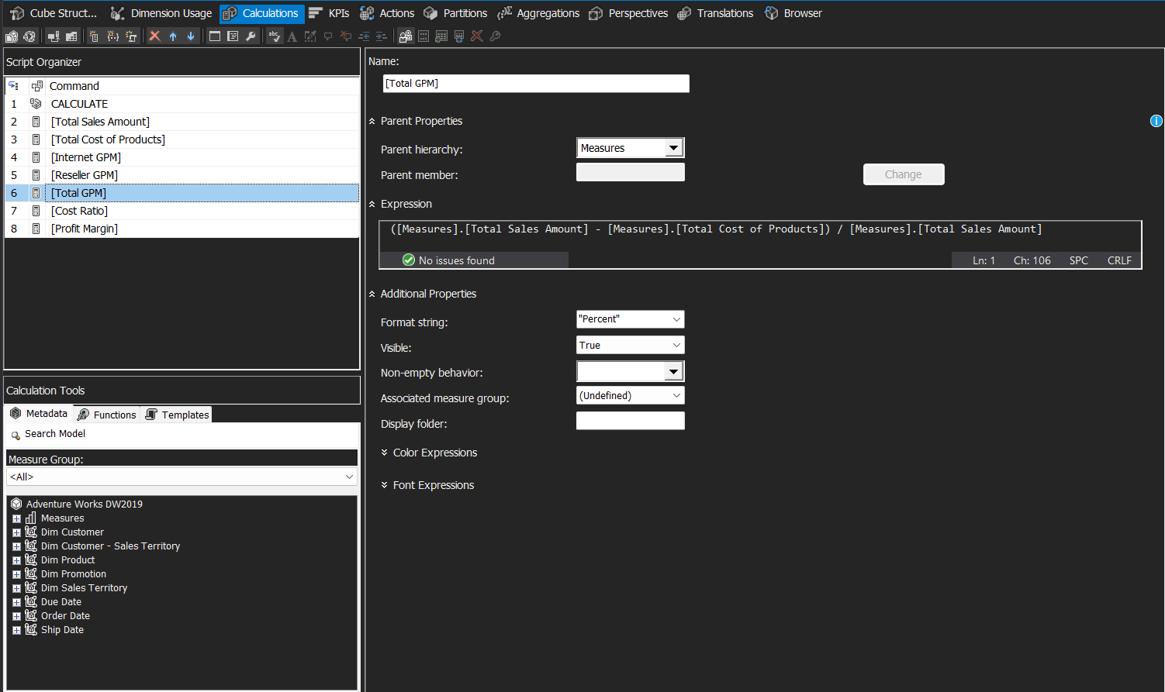

Figure 24: Total GPM

Figure 24 demonstrates Total GPM" calculated measure that provides an overall gross profit margin calculation using the formula (Total Sales Amount - Total Cost of Products) / Total Sales Amount. It is formatted as percentage to deliver enterprise-wide profitability metrics across all sales channels.

### 3.5.6: Cost Ratio’s Calculation

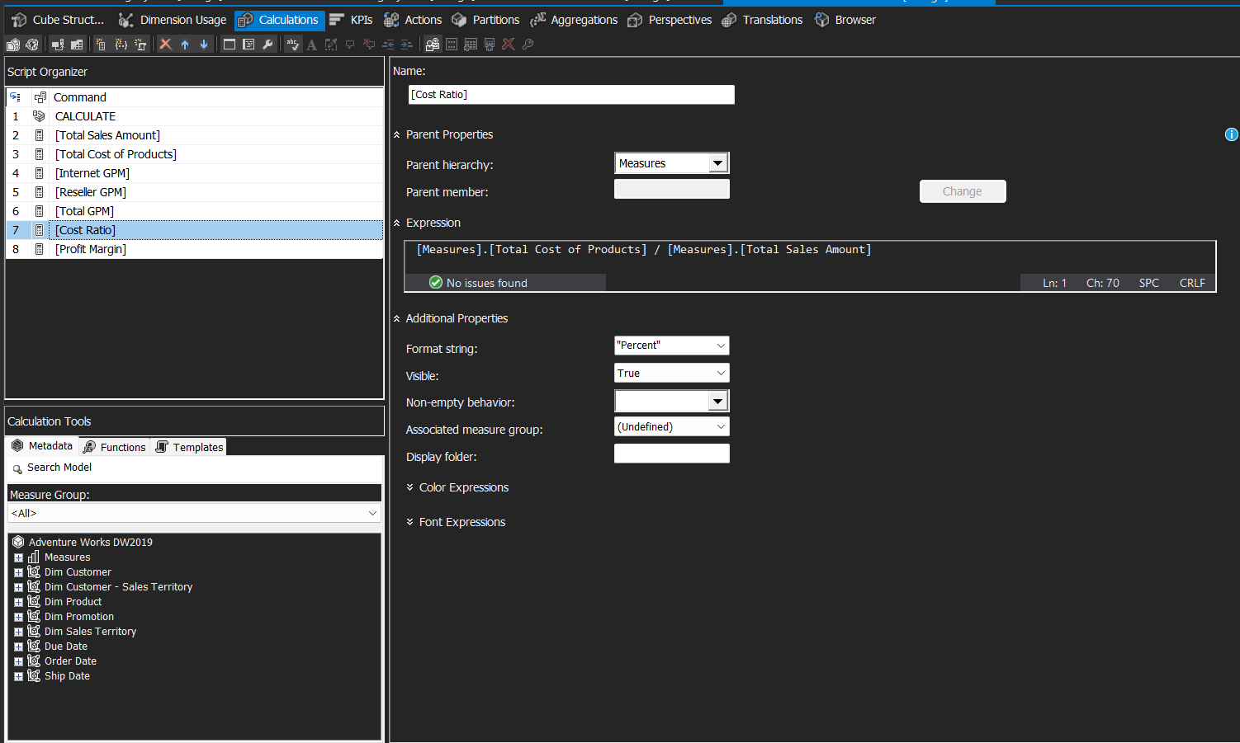

Figure 25: Cost ratio

Figure 26 shows the calculated measure setup for “Cost Ratio” where it calculates the relationship between total costs and total sales using the expression Total Cost of Products / Total Sales Amount. The cost ratio is formatted as percentage to analyse cost efficiency and expense ratios.

### 3.5.7: Profit Margin’s Calculation

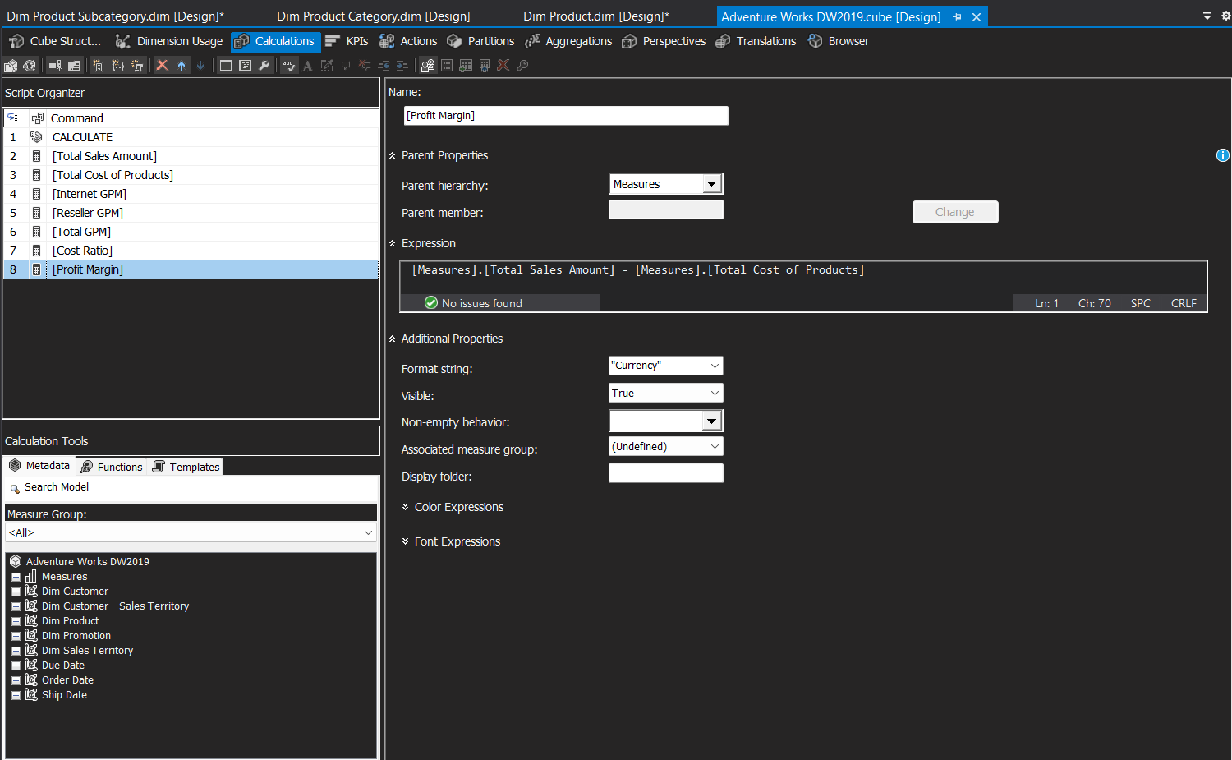

Figure 26: Profit Margin

Figure 26 shows “Profit Margin” calculated measure which computes absolute profit by subtracting Total Cost of Products from Total Sales Amount. It is formatted as currency to provide the actual monetary profit value for financial analysis and reporting purposes.

# **4.0: Business Intelligence Report (Analysis)**

## 4.1: Overall Report for AdventureWorks

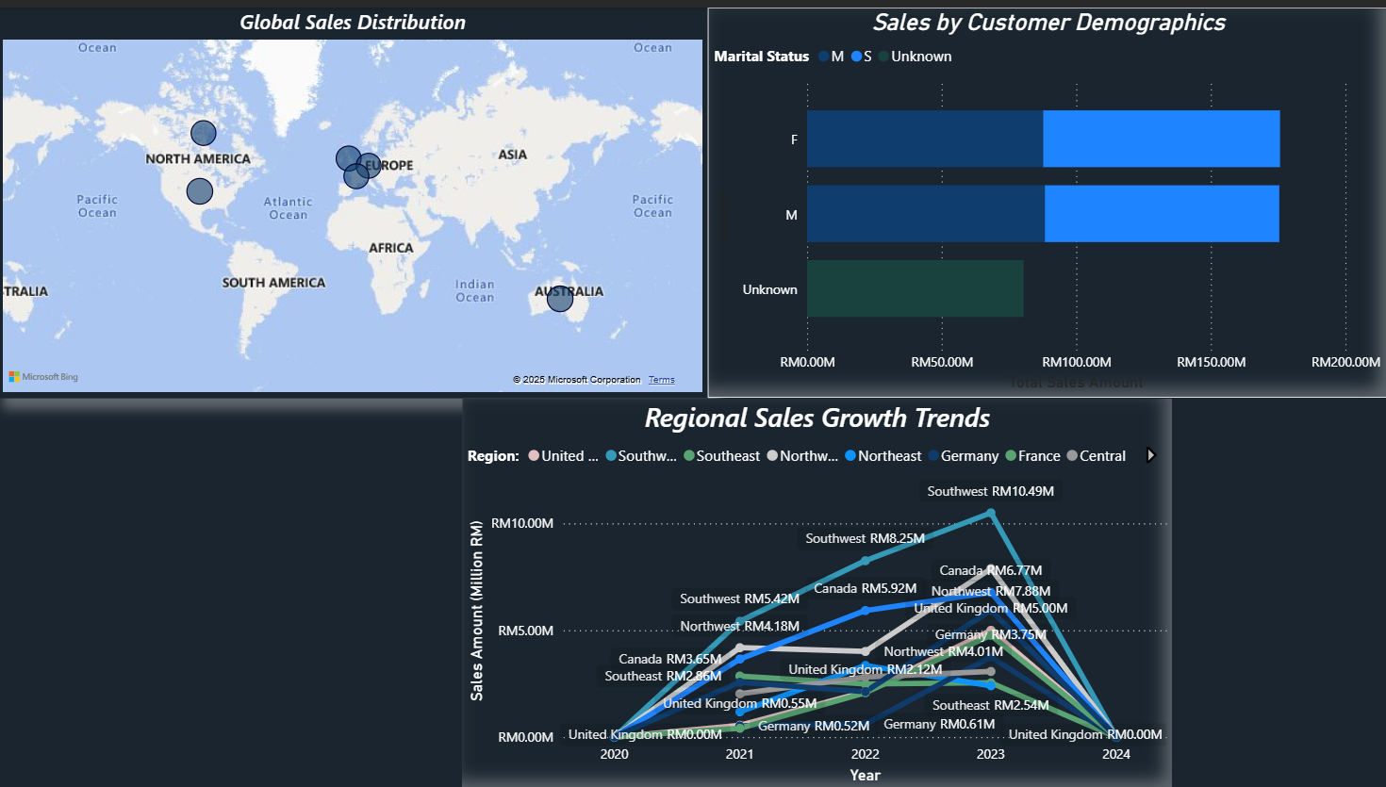

Figure 27: Overall Market Analysis Report for AdventureWorks

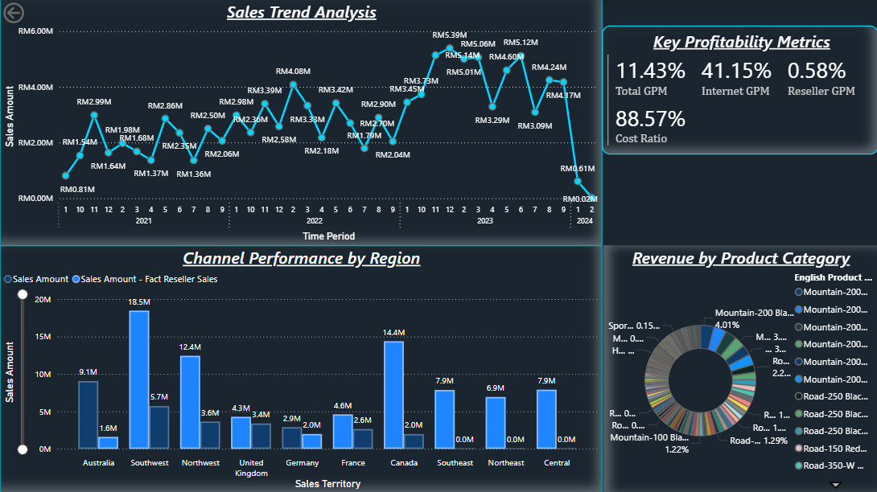

Figure 28: Financial Performance Report for AdventureWorks

The first image shown in Figure 27 displays the financial backbone layout of AdventureWorks, illustrating where all of their sales are occurring worldwide, their customers, and how each region has grown over the years. This information will help AdventureWorks identify the strongest market and also assess those that are just getting started.

The second image shown in Figure 28 presents the expansion strategy for AdventureWorks, which details the overall sales trend of the company, measures profitability by channel and region, and compares sales for internet sellers and resellers. Additionally, it breaks down revenue by product category. Using all of these key indicators, we can identify which market to target, which channel to move in, and which product to push.

## 4.2: Global Sales Distribution Report

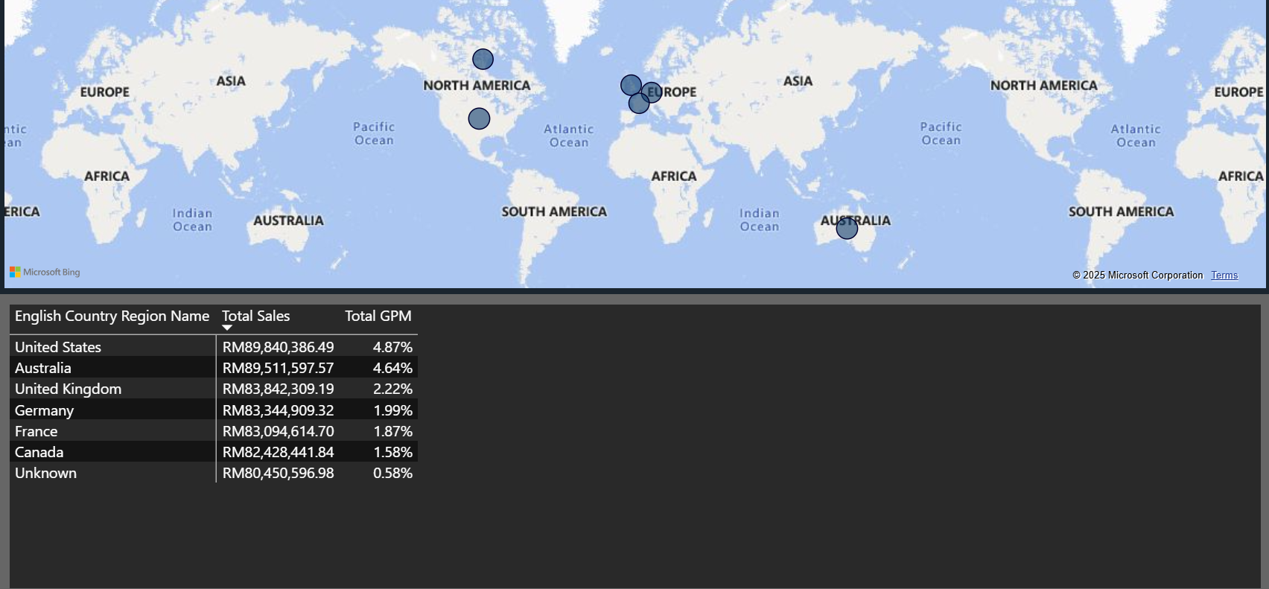

Figure 29: Global Sales Distribution

The global sales distribution map presents six concentrated major markets. One of them, which is at the top, is the United States, leading at 89.84M Malaysian ringgit which holds 55% of the market share, followed closely by Australia with 89.51M ringgit and the United Kingdom with 83.84M ringgit. The visualization also shows established markets that are situated in Germany with 83.34M Malaysian ringgit, France with 83.09M Malaysian ringgit, and Canada with 82.43M Malaysian ringgit. The visualization shows data with an unknown segment that has around 80.45M in sales. These distribution results show that a high concentration of market for English-speaking countries, such as the United States, Australia, the United Kingdom, and Canada, is seen compared to the market in Europe, where a handful of countries, such as Germany and France, are seen with a high concentration of market but lower than the English-speaking ones. The graph also represents the highest sales volumes with moderate profitability for the United States and Australia, with a total GPM of 4.87% and 4.64% respectively, while the unknown segment showed a significant revenue of 80.45M but with a low profitability margin of 0.58%.

The recommended business approach is to focus on countries that have high performance in sales and prioritize markets that can achieve profitability levels similar to the United States (4.87%) and Australia (4.64%). Run an investigation on the unknown segment that represented 80.45M Malaysia Ringgit to identify specific geographic opportunities for making better decisions in future expansion, and check out the reason behind Canada’s low gross profit margin and fix any issues that might hurt profitability in similar markets as well.

## 4.3: Regional Sales Growth Trends Report

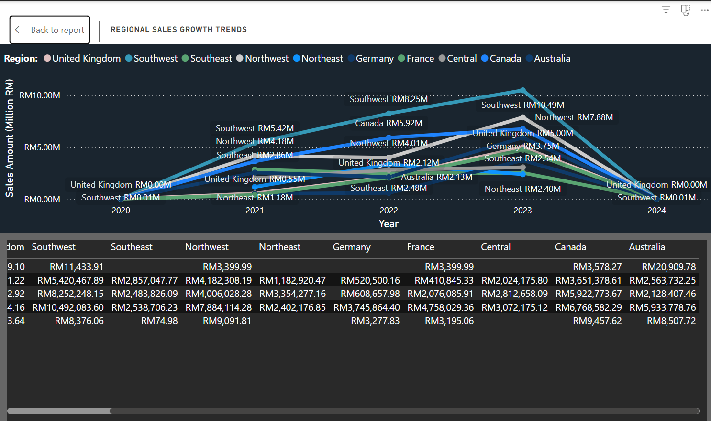

Figure 30: Regional Sales Growth Trends

The year and regional visualization performance tracks sales for ten distinct territories from the year 2020 to the year 2024. The graph reveals both the success story and the alarming market disruption of AdventureWorks. Among all of the 10 distinct territories, the southwest region emerges to be a standout performer that grew from 11.43 thousand ringgit to 10.49 million from the year 2020 to 2023. Canada, on the other hand, maintains a consistent sales increase that rose from 3.65 million in the year 2021 and rose up in sales by 6.77 million in the year 2023. The northwest also showed an impressive upward momentum that moved from RM3,399.99 in 2020 to RM7.88 million in 2023, which increased by 132%.  Even for other countries such as France, Germany, United Kingdom, their profit all jumped to millions from the year 2020 to 2023. The central region, on the other hand, also grew in double the sales from the year 2021 to the year 2023, where it jumped from 2.02 million to 3.07 million, where the sales grew more than double.  The growth pattern from 2020 to 2023 for all countries increased in huge numbers, which opens up the possibility to expand AdventureWorks’ businesses across various global regions, but the sharp decline from the year 2023 to 2024 for all territories provided the urgent need for a global expansion.

To solve this problem at first, we have to:

1. Focus on regions that are in their best performance and investigate what factors influenced   
 to reach of this huge peak, such as sales strategies, product offerings, customer engagement   
 approaches, or marketing campaigns used in Southwest, Canada, and Northwest. Then   
 reapply or investigate a new approach to slower-growing regions to help boost their   
 performance. This could include training local teams, adapt promotions, or improve supply   
 chains in those markets.

2. Delay the expansion plan until the investigation for the post-2023 decline is fully analysed   
 so that the company can understand what was the main cause for this huge drop in sales in   
 the overall market and help to address this issue. Expanding the market without solving the   
 issue could lead to a bigger risk for losses, so it's mandatory to figure out whether the main   
 causes were due to economic conditions, supply chain issues, data errors, etc.

## 4.4: Customer Demographics Report

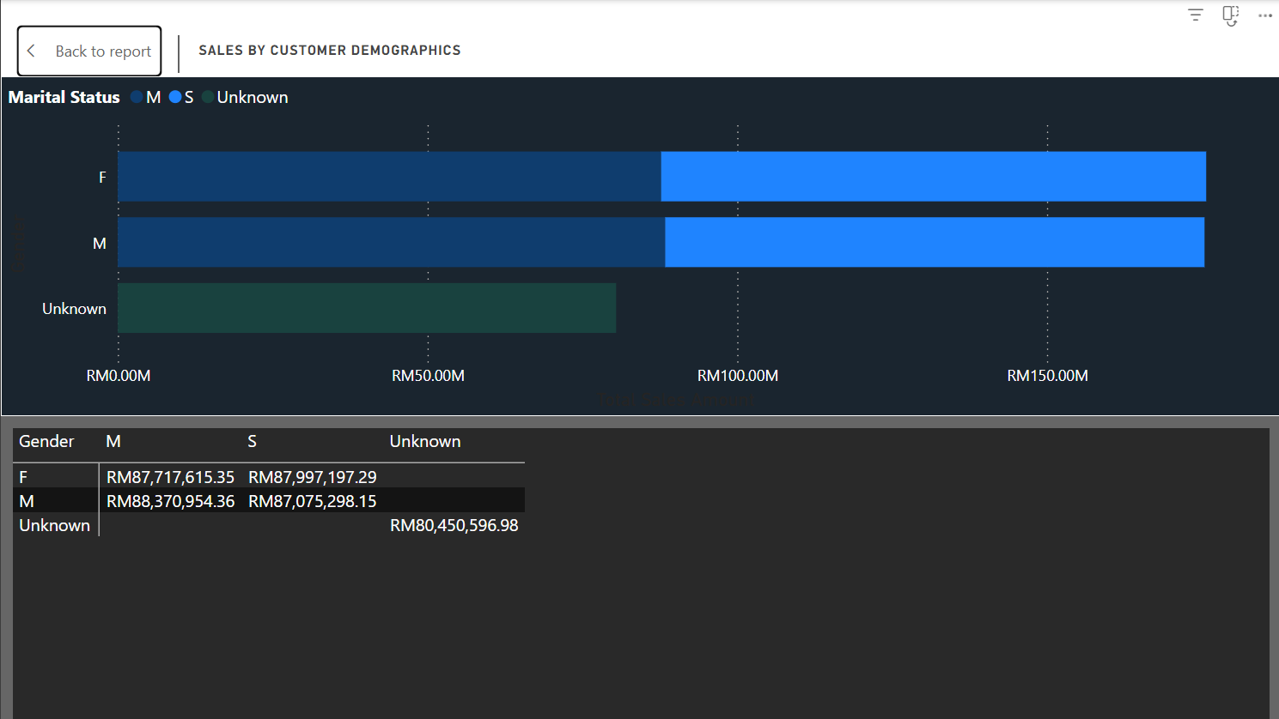

Figure 31: Sales By Customer Demographics

The customer demographics graph shows a crucial insight into AdventureWorks' consumer base, where it has revealed that it has a surprisingly balanced gender distribution, with female customers contributing RM175.71 million while male customers generate RM175.45 million. These statistics demonstrate the company's successful positioning for both genders to have a balanced distribution that goes beyond traditional male-dominated cycling markets. The marital status for married customers has a total sale of RM176.09 million, which slightly outperforms the single customers that have a total sale of RM175.07 million, suggesting that AdventureWorks has a broad market that resonates equally for all life stages of customers. Gender parity provides a significantly strong foundation for global expansion into markets. A significant RM80.45 million (18.6%) of revenue comes from customers whose demographic data is incomplete or unclassified, which leads to poor data quality. This would limit the ability to perform fine-grained customer profiling and forecasting, and miss out on important targeted opportunities that would be beneficial for strategizing for global expansion.

The recommended step to enhance customer profiling is to check out for details shown in forms, targeted surveys and loyalty programs. Retrieve all of that information and insert them into the database. Afterwards use the data to refine the customer demographics to align with the market demand which would be helpful for global expansion.

## 4.5: Yearly Sales Trend Analysis Report

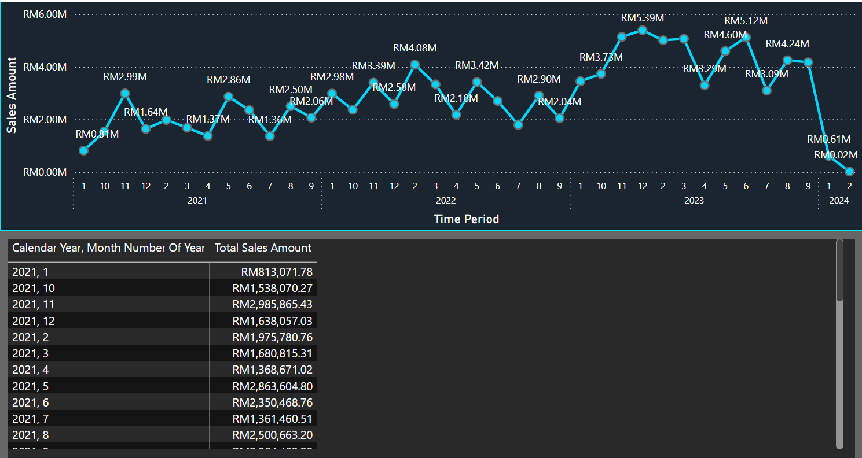

Figure 32: Sales Trend Analysis

The graph provides an in-depth presentation of the company’s overall sales trend from January 2021 through February 2024, where it reveals a critical seasonal pattern that is essential for inventory planning and market expansion timing. The months are numbered as 1 for January, 2 for February, and so on. The visualization shows that there is a consistent peak around December 2023, where it achieved a record of RM5.39 million in monthly sales. This validates that during the holiday season, demand for AdventureWorks' premium bicycles is higher compared to other busy months. There is a sharp decline that has been seen around January 2024, which showed a 99.6% revenue collapse from RM 5.12 million.

The recommended step is improving the operational planning, where AdventureWork should develop market-specific seasonal sales models, which would help the business to address the unique characteristics of each expansion territory. The model should account for local cycling seasons, weather conditions, and cultural buying behaviours to ensure more accurate demand forecasting and timely product availability. The company should increase its production and increase manufacturing capacity and inventory levels by 40% during high demand spikes around holiday seasons to fully capitalize on peak seasonal sales and avoid missed revenue opportunities.

## 4.6: Key Profitability Metrics Report

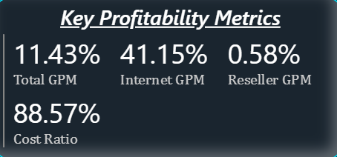

Figure 33: Key Profitability Metrics

The key profitability metrics dashboard displays four crucial performance indicators for AdventureWorks. These include Total Gross Profit Margin, standing at 11.43% which is the overall profit of the company across all sales channels. The Internet channel shows exceptional performance with a 41.15% GPM, while the Reseller channel severely underperforms at just 0.58% GPM. The Cost Ratio of 88.57% reveals that nearly 89% of revenue goes toward costs where there is a limited profit margin and expansion investments.

The significant gap between the Internet and the Reseller channel profitability indicates which channel to target for future growth. The Internet channel generates 70 times better profit margins than Reseller operations. AdventureWorks should focus on expanding its business more towards the Internet channel to leverage its 41.15% profit margin. Improve operational efficiency to reduce the 88.57% cost ratio in order to free up enough capital for expansion. The team of AdventureWork should set a target of achieving at least 15% Total GPM before entering new markets.

## 4.7: Channel Performance by Region

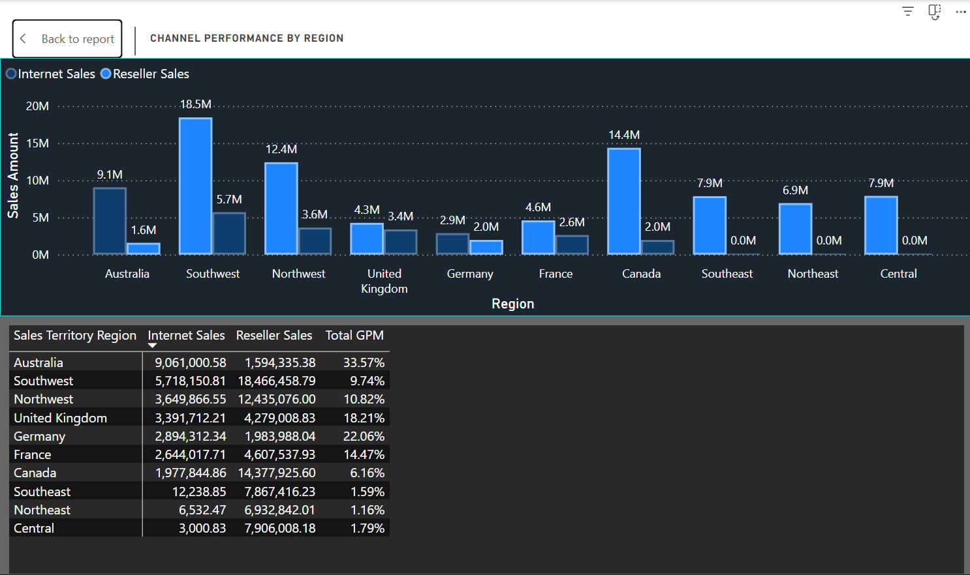

Figure 34: Channel Performance by Region

The visualization provides crucial insights for AdventureWorks' market entry strategies that have continuous variations in channel effectiveness across territories. The Southwest region has an imbalance channel where Reseller sales (RM18.47 million) are way more than Internet sales (RM5.72 million), even though Internet sales have a superior profit margin than reseller sales, which is shown in Figure 33. On the other hand, Australia achieves the highest regional GPM at 33.57% which shows that there is a high potential for profitable operations. The lower sales for resellers in Southeast, Northeast, and Central regions suggest that there are market limitations or bad strategic channel decisions have been made that have resulted in extremely low profit margin (1.59% to 1.79% GPM). The chart reveals that the AdventureWorks expansion will heavily depend on adapting channel strategies to local market conditions. Germany's balanced approach, where reseller sales (RM1.98M) are closer to that of internet sales (RM1.98M), achieves a 22.06% GPM. This can act as a replaceable model for European expansion. The correlation between reseller dominance and lower profitability is seen across regions, with reseller-heavy markets like Canada having (RM14.38M) more reseller sales than (RM1.98M) that of Internet sales, which shows a poor GPM performance of 6.16%.

The statistics and the pattern shown in the channel performance strongly support adopting for digital-first expansion strategy to maximize profitability in new markets. Study more on how Australia's channel mix formula (RM9.06M Internet, RM1.59M Reseller) achieves 30%+ GPM, where it will later on act as a template to hunt down the new markets in the expansion process.

## 4.8: Revenue By Product Category

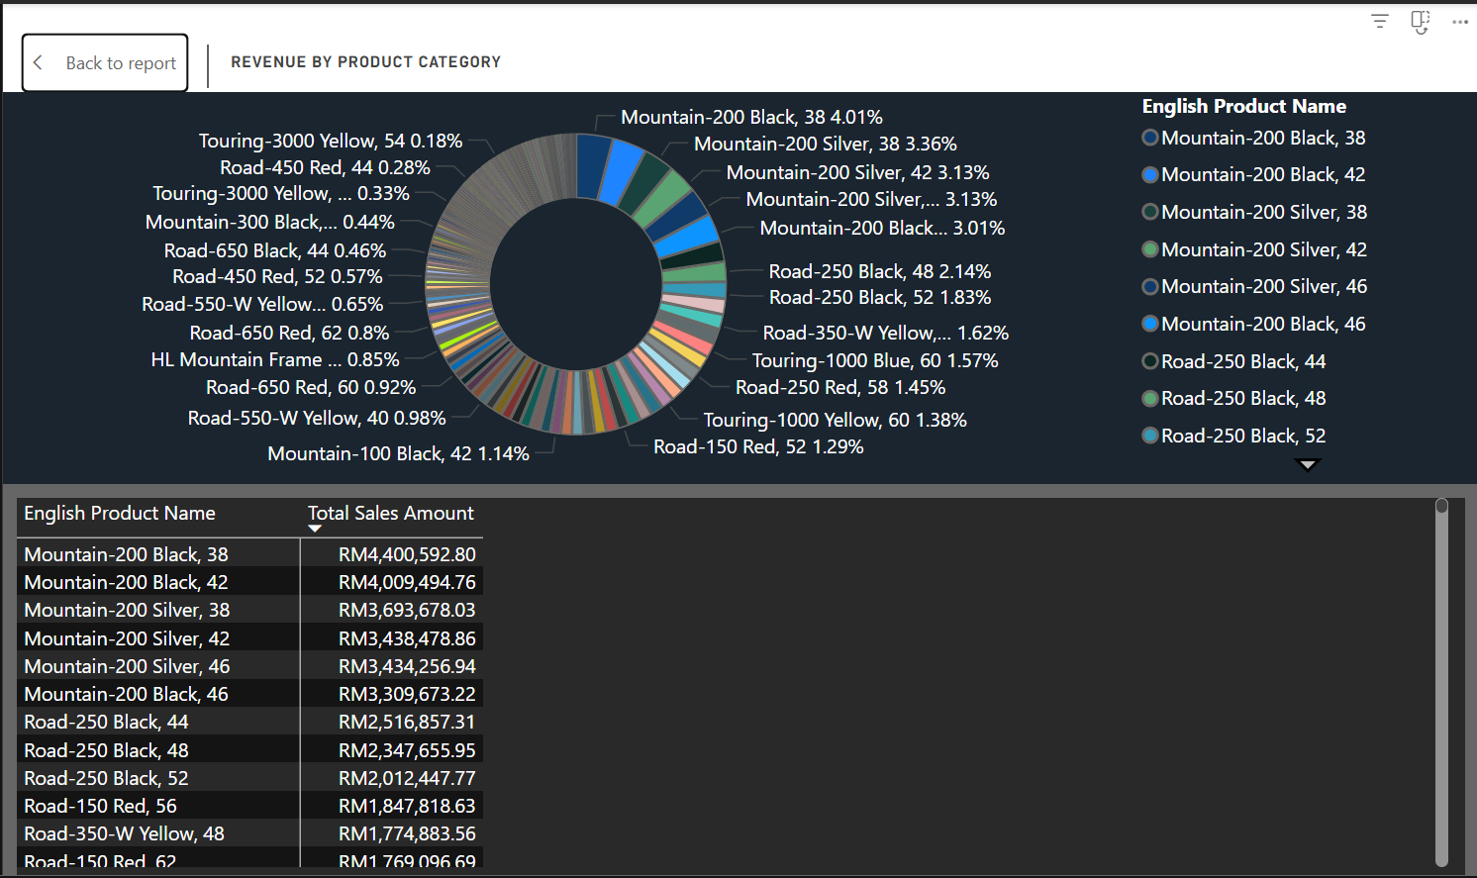

Figure 35: Revenue By Product Category

The product portfolio visualization reveals AdventureWorks' heavy concentration in specific bicycle categories with high revenue generation. One of them includes the Mountain-200 and Road series. The top five products (Mountain-200 Black 38, Mountain-200 Black 42, Mountain-200 Silver 38, Mountain-200 Silver 42, and Mountain-200 Silver 46) collectively generate RM18.98 million, which represents 43.7% of visualized revenue. This reflects strong market acceptance for the 200-series bicycle but also raises concerns about portfolio concentration risk that could impact flexibility for market expansion. The Road bike series shows strong performance with Road-250 Black variants contributing RM6.88 million combined, while specialty categories like Touring bikes represent a minimal revenue share. The concentration of the products presents both opportunities and risks for global expansion. While the dominance of the 200-series bicycle provides a reliable foundation for global expansion, it limits the flexibility to adapt to diverse international markets. Strong focus on mountain bikes may not align with the demand for urban-focused markets, such as in Europe and Asia, where road bikes, hybrids, e-bikes, and compact folding bicycles are in greater demand due to dense city environments and cycling infrastructure.

In order to solve this issue, AdventureWorks needs to do intensive research on local cycling preferences and infrastructure to guide SKU selection, which would develop the market-specific product portfolios in order to expand to respective territories. Invest in R&D to create region-specific variants of successful 200-series products in order to analyse local terrain and usage patterns. Expand the business to include urban-focused categories, which would be essential for Asian and European markets.

# **5.0: Conclusion**

The implementation of Business Intelligence solution for AdventureWorks has transformed the company's raw data into actionable insights which is crucial for its global expansion strategy. AdventureWorks now possesses a robust analytical framework that provides real-time visibility into sales performance, customer demographics, channel profitability, and regional market dynamics due to the deployment of a SSAS multidimensional cube integrated with Power BI dashboards.

The PowerBI revealed several critical findings that directly impacts AdventureWorks' expansion plans. The company's current revenue concentration is in six primary markets such as United States, Australia, United Kingdom, Germany, France, and Canada. This demonstrates that company has a strong foundational presence but highlights significant gaps in Asian and South American markets. The profitability between Internet (41.15% GPM) and Reseller (0.58% GPM) channels provides clear direction for a digital-first expansion strategy. However, the catastrophic 99.6% revenue decline in early 2024 requires an immediate investigation and resolution before any expansion initiatives can proceed. This proposed system enabled AdventureWorks to make data-driven decisions through interactive dashboards that track key performance indicators including Total Sales Amount, Gross Profit Margins by channel, regional growth trends, and customer segmentation patterns. This system enables the company to achieve its strategic objectives by providing the analytical capabilities necessary to identify optimal expansion markets, maximize channel profitability, and respond quickly to market disruptions.

By using all of the insights gained from the Business Intelligence System, AdventureWorks can confidently pursue its vision of transforming from a US-dominant manufacturer with 55% market share to a truly global cycling industry leader, while maintaining the operational excellence and innovation. This would equip the company for domestic success.

# **6.0: References**

Chumbar, S. (2023, September 24). The CRISP-DM Process: A Comprehensive guide - Shawn   
 Chumbar - medium. *Medium*.

<https://medium.com/@shawn.chumbar/the-crisp-dm-process-a-comprehensive-guide-4d893aecb151>

*Definition — the Crisp-DM methodology*. (n.d.).

<https://almirgouvea.github.io/The-Crisp-DM-Methodology/chapters/definition.html>  
Mercedes-Benz Group. (n.d.). *The Board of Management of Mercedes-Benz Group AG |*

*Mercedes-Benz Group*.

<https://group.mercedes-benz.com/company/corporate-governance/board-of-management>

Sharma, R. (2025, March 13). *CRISP-DM explained: A proven data mining methodology*. Udacity.

<https://www.udacity.com/blog/2025/03/crisp-dm-explained-a-proven-data-mining-methodology.html>

**Word Count:** 4976